LEVITT AMP SPRINGFIELD
BRIDGE GRANT – REPORT

My organization received $1,000.00 from the Levitt Foundation bridge grant as part of the Levitt AMP Springfield program. That amount was spent thusly:

Amount (in dollars) | Item or Service Purchased

My organization and its clients benefited in these ways from the grant:

Total number benefiting _____ Number of males _____ Number of females _____

Ages represented __________ Racial groups represented ________________________________________

Organization

By Title

Signature Date

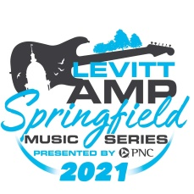

SPRINGFIELD AREA ARTS COUNCIL DOWNTOWN SPRINGFIELD HERITAGE FOUNDATION
420 South Sixth Street Springfield, IL 62701 227 South Seventh Street Springfield, IL 62701
217-753-3519 217-544-1723
programs@springfieldartsco.org heritagefoundationspi@gmail.com

